

**FENGINEERING REPORT FOR THE SHARP MOUNTAIN WATERSHED RESERVOIR NO.12 REMEDIATION**

**_____________________________**

**PREPARED BY**

**GMB ENGINEERING**

**GABRIELLE USHER**

**MARY BURNAM**

**REBEKAH WILLIAMSON**

**_____________________________**

**A report submitted to the University of Georgia, College of Engineering in partial fulfillment of Senior Design course requirements**

**Spring 2020**

1. ACKNOWLEDGEMENTS

We would like to express our gratitude to all the faculty and staff at the University of Georgia who have provided guidance and support for our project, including Dr. Stephan Durham, Dr. Brian Bledsoe, and Dr. David Gattie. We would also like to thank the engineers at Natural Resources Conservation Service, Mr. Eric Harris, Ms. Molly Dawson, Ms. Diane Guthrie, and Mr. Justin Robinson, as well as Greg Walker from the Georgia Soil and Water Conservation Commission, for aiding in us in data collection, software navigation, and site exploration.

Table of Contents

I. Project Background 1

A. Client 1

B. Initial Site Visit 1

II. Purpose 3

III. JURISDICTIONS HAVING AUTHORITY 4

IV. APPLICABLE CODES 5

V. Findings 7

A. Existing Conditions 7

C. Concept 1: Restore Dam Capacity 11

D. Concept 2: Drinking Water Reservoir 15

VI. RecomMendations 20

VII. Costs 21

VIII. Future Work 22

IX. Disclaimer 23

X. Conclusion and SUmmary 24

XI. Exhibit 1: Site LOcation 26

April 15, 2020

Mr. Eric Harris, P.E.

State Conservation Engineer

U.S. Department of Agriculture

Natural Resources Conservation Service

355 East Hancock Avenue

Athens, GA 30601

RE: Final Report of Findings & Recommendations

Sharp Mountain Watershed Reservoir No.12 Dam Remediation

Jasper, GA 30143

Greetings Mr. Eric Harris:

On behalf of the University of Georgia College of Engineering and GMB Engineering, we would like to thank you for the privilege of analyzing potential modifications and plans to remediate Sharp Mountain Watershed Reservoir No.12 Dam as part of our Senior Design project. The purpose of our involvement was to present data, designs, and research alternatives to restore the dam within safe and acceptable standards, as well as propose plans for a drinking water reservoir. As part of our investigation we performed a site visit on November 21, 2019 and also met with other stakeholders, such as Lonnie Waters with the City of Jasper and Greg Walker with Georgia Soil and Water Conservation Commission, to obtain the background information on the project. This report contains our findings, conclusions, and recommendations.

We hope that you find this report satisfactory.

Sincerely,

Gabrielle Usher

Mary Burnam

Rebekah Williamson

# Project Background

## Client

The United States Department of Agriculture - Natural Resources Conservation Service (NRCS) requested that engineering solutions, designs, and analyses be presented to remediate Sharp Mountain Watershed Reservoir No.12 Dam as the NRCS conducts the Watershed Rehabilitation Program. This dam is earthen and was considered hazard classification A when constructed in 1960. It was built to control flooding on adjacent agricultural lands and is currently owned by the city of Jasper, Georgia. The city owns approximately 14.75 acres where the dam sits. The dam is not functioning as designed and now has hazard classification C, meaning that dam failure can cause serious loss of life and damage to property. The dam must be fixed in order to restore its functionality and protect human and environmental health. The city of Jasper, with the guidance of NRCS, hopes to use the reservoir created by the dam as a source for drinking water, so design plans to construct a suitable capacity for drinking water, channel lining and sizing, and a forebay will be considered in this report.

## Initial Site Visit

During the initial site visit in November, the city of Jasper informed the group on their hopes to use the reservoir as a drinking water source as Pickens County does not have a public lake, reservoir, or river. At the time of the visit, the reservoir was filled with water because of recent rainfall and lack of drainage, and the observed water quality seemed to have relatively good as shown by its clear visibility. However, as asserted by Mr. Eric Harris, the water level should have been 3 to 4 feet lower. This was due to the build-up of sediment. The dam’s riser was not visible and completely buried by an estimated 4 feet of sediment. When examining the natural channel at the rear of the property, significant bank erosion showed a lack of red clay layers. This debunked the previous notion that nearby construction on adjacent properties in the early 2000s was the main contributor of built-up sediment in the reservoir. Because of this, it is now a concern that sedimentation will continue to occur at a similar rate. Near the channel, there was a small waterfall overtopping a previously constructed stone wall. The original purpose of this wall is unknown.

# Purpose

The purpose of the Sharp Mountain Watershed No.12 Dam Remediation is to critically evaluate different ideas that can fix the dam from using the emergency spillway, which is currently being activated every time the dam experiences high flow rates. In practice, the emergency spillway should only be used once or twice in the dam’s lifetime and according to documentation on the dam in 1960, the percent chance of primary emergency spillway use is 4%. The massive amount of sediment that has accumulated combined with the current sediment that still flows into the reservoir presents another problem that must be solved. Plans to not only provide solutions that will create alternate spillways, reduced sedimentation, and optional plans that create an effective drinking water reservoir are included in this report. Hydrologic and hydraulic analyses, information output from WinTR-55, a soil survey using data from the USDA, and GIS mapping are included to justify design choices, calculations, and costs.

# JURISDICTIONS HAVING AUTHORITY

The following authorities have jurisdiction over this project:

1. United States Department of Agriculture, Natural Resources Conservation Service

Contact: Eric Harris, Assistant State Conservation Engineer

Office: 706-546-2091

Email: [eric.harris@usda.gov](mailto:eric.harris@usda.gov)

1. United States Forest Service

Contact: Towdy Tipton

Office: 706-745-6928

Email: [towdytipton@fs.fed.us](mailto:towdytipton@fs.fed.us)

1. Georgia Soil and Water Conservation Commission

Contact: Jessica Mimbs

Office: 706-286-2858

Email: [jessica.mimbs@gaswcc.ga.gov](mailto:jessica.mimbs@gaswcc.ga.gov)

1. Pickens County Planning and Development Office

Contact: Rodney Buckingham, Planning and Development Director

Office: 706-253-8850

Email: [rbuckingham@pickenscountyga.gov](mailto:rbuckingham@pickenscountyga.gov)

1. Georgia Environmental Protection Division

Office: 404-463-1511

# APPLICABLE CODES

1. Code of Ordinances of Pickens County, Georgia

A. Chapter 26: Environment

B. Chapter 38: Land Development Standards

C. Chapter 67: Land Use Intensity Districts and Map

1. Georgia Stormwater Management Manual (GSMM)

A. Chapter 2.4: Integrating Post-Construction Stormwater Management

B. Chapter 2.6: Other Regulatory Requirements

C. Chapter 4: Implementing Stormwater Management Requirements for Developments D. Chapter 5: Elements of Stormwater Management Programs

1. Georgia Soil and Water Conservation Commission (GSWCC)

A. Chapter 2: Sediment and Erosion Control Processes, Principles, and Practices

B. Chapter 3: Planning and Plans

C. Chapter 6: MBP Standards and Specifications for General Land-

Disturbing Activities

1. Official Code of Georgia Annotated

A. Title 12: Conservation and Natural Resources

1. Chapter 3: Parks, Historic Areas, Memorials, and Recreation

2. Chapter 5: Water Resources

3. Chapter 6A: Land Conservation

4. Chapter 7: Control of Soil Erosion and Sedimentation

5. Chapter 16: Environmental Policy and Regulations

B. Title 27: Game and Fish

C. Title 44: Property

1. Chapter 10: Historic Preservation

1. Natural Resources Conservation Service - National Engineering Manual

A. Part 501: Authorizations

B. Part 503: Safety

C. Part 504: Special Investigations, Studies, and Reports

D. Part 510: Planning

E. Part 511: Procedures

F. Part 520: Soil and Water Resource Development

G. Part 530: Hydrology

1. Code of Federal Regulations

A. Title 36: Parks, Forests, and Public Property

1. Chapter 2: Forest Service, Department of Agriculture

2. Chapter 3: Corps of Engineers, Department of the Army

B. Title 40: Protection of the Environment

1. Chapter 1: Environmental Protection Agency

# Findings

## Existing Conditions

The current earthen dam, located at 34.4400914 latitude and -84.4415925 longitude, has a drainage area of approximately 3800 acres (5.94 square miles). Towns Creek flows into the dam. The height of the dam is 66 feet and the original dam design had a dead pool volume of 102 acre-feet. Each emergency spillway has a width of 100 feet and a flow capacity of 2500 ft3/s. The riser, although buried beneath sediment, is 22 feet high. It uses a 24” RCP to drain water out of the dam.

* 1. Hydrologic Analysis

The hydrology of the watershed was analyzed in order to determine peak flow statistics, which are used in the design solutions. The data collected from this portion of the report was analyzed using USGS StreamStats and WinTR-55.

Figure 1: StreamStats Watershed Delineation

StreamStats was initially utilized to gather more data regarding the watershed. Figure 1 shows the delineated watershed which uses the Sharp Mountain Reservoir No. 12 as its outlet. The area of the watershed is approximately 5.64 square miles, mainly consisting of forested land, pasture, and rural residential communities.

Although StreamStats provides current information on the watershed, the scope of the project is to retrofit the dam to function indefinitely. Therefore, the dam will be designed based on future development in the watershed. As Pickens County is only an hour away from Atlanta, the city anticipates significant future residential and commercial growth. Based off of current commercial/residential areas in the watershed, it is anticipated that in the next 10-20 years land use will be divided up into about 36% commercial/business, 46.6% residential areas (divided up between 1 and 2 acre lots), 8.7% forested land, and 8.6% pasture. Figure 2 depicts our land use estimations. The land use areas used are: 1307 acres commercial/business, 900 acres 1-acre residential lots, 790 acres 2-acre lots, 314 acres wooded area in fair condition, and 312 acres pasture-land in fair condition.

Figure 2: Future Land Use Estimations

Using these future land use areas, a curve number was obtained by an analysis using WinTR-55. In order to calculate the curve number, the soil groups were identified using the USGS Web Soil Survey. The different soil groups in the watershed are shown in *Figure 3*. Based off of the data, the area consists of about 30 different soil types with the majority being 15.2% Tallapoosa sandy clay loam, 13.2% Hayesville fine sandy loam, 9.2% Chewacla-Cartecay complex, and 6.2% Madison fine sandy loam. The typical soil subgroup is type B. Inputting this information into WinTR-55 gives a curve number of 75. Due to the anticipated urbanization of the area, this is much higher than the current curve number of 66 for the watershed.

Figure 3: Soil Survey

Next, the total time of concentration from the watershed was calculated using WinTR-55 (*Figure 4*). The flow parameters input into the software include the length (ft), slope (ft/ft), and Manning’s n for sheet, shallow concentrated, and channel flow. With these values, a time of concentration of 1.671 hours was obtained. After inputting all the parameters, a hydrograph representing peak flows for each design storm, shown in *Figure 5*, was produced. The resulting 100-year peak flow of 6,557.36 cfs will be utilized when designing the dam capacity and storage.

Figure 4: WinTR-55 Data (Time of Concentration and Weighted Curve Number)

Figure 5: WinTR-55 Hydrograph

## Concept 1: Restore Dam Capacity

* + 1. Complete Excavation/Dredging

The first concept includes complete excavation or dredging of the reservoir in order to increase the capacity of the dam and restore functionality. If water levels are low or the water is removed, the sediment can be excavated using earth-moving excavation machinery such as a backhoe. The cost for excavation is approximately $10 per yd3. However, if the water is not removed, mechanical or hydraulic dredging could be utilized. A hydraulic dredge usually consists of a dredge head and a hydraulic pump. The dredge head is lowered into the bed to fluidize the sediment to draw the slurry into the suction pipe. This process typically costs $14 per yd3.

The riser is 22 feet tall and estimated to be under 4 feet of sediment which gives us an approximate sediment accumulation of 26 feet across the original normal pool span of 2.3 acres. The volume of sediment estimated needed to be removed is 2,604,888 ft3. For dredging, the cost estimation is $1,350,682 and for excavation, the total cost estimation is $964,773.

During the November site visit, it was discovered that the sediment that has filled the dam is very nutrient rich and contains little to no clay. For this site in particular, transporting and dumping the sediment is not needed which eliminates a large expense typically associated with dam excavation and dredging. This leaves a few different possibilities for disposal of the sediment. One possibility is to sell the dried sediment to as nutrient-rich topsoil. In a case studied by the EPA, dredged soil was dried and sold as topsoil for $2 per yd3. The profit from selling the sediment as topsoil for this case would be approximately $192,955. Another option is to spread a 4-6 inch layer of sediment across the powerline easement that is adjacent to the dam. This means that the cost for complete sediment removal ranges from $771,818 based on excavation and selling the sediment as topsoil all the way up to $1,350,682 based on dredging and distributing sediment along the powerline easement. The final option includes using the dirt for landfills which has an average cost of $32 per ton. This cost would be $3,382,603.

* + 1. Increase Height of the Dam Spillway

Another alternative would be to leave the sediment in the reservoir and increase the capacity of the dam by increasing the dam height. An alternative outlet control structure would need to be installed in order to allow drainage. Adding a number of parallel pipes on the addition would allow the excess water to be drained from the dam. The size and number of these pipes still need to be determined based on the amount of flow that needs to be drained, but a rough sketch can be seen in *Figure 6*. In this figure, the red is the addition to the height of the dam and the light grey circles are the approximate location of the pipe series used to drain water. This figure is the front view of the dam and is not to scale. When building up the height of the dam to accommodate more water, an addition to the front must also be made to counteract the additional pressure of the water behind the dam. The elevation of the emergency spillway would need to increase so it is not continually activated.

Figure 6: Front View of Alternative Spillway

In *Figure 7*, a side view of the dam is shown with a possible sketch of the addition. The pipes that are running in parallel would go across the crest of the dam and down the front matching the 3:1 slope within the earthen addition. The outlet of these pipes would tie into the current 24” RCP running from the blocked riser downstream from the dam. Within each individual pipe, an air vent is needed to allow water and air flow. In *Figure 7*, the blue pipes are laid within the 6-foot addition and the pink air vents are on the top of the dam. These pipes could also be added within the original dam structure in order to have a lower normal pool depth. The concept is the same, and height of the pipes relative to the bottom of the dam can be determined from further analyses.

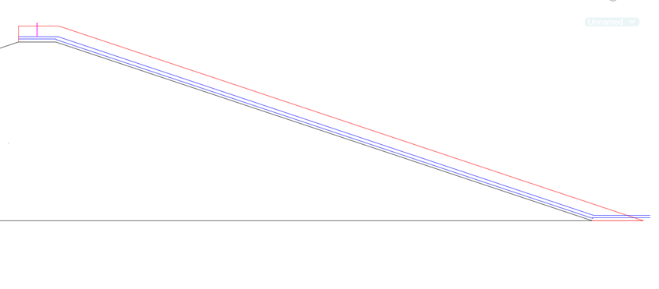

Figure 7: Side View of Alternative Spillway with Red Addition

If the dam were to be raised by 6 feet along the top as well as 6 feet on the front of the dam, the total amount of dirt needed is 25,586 yd3. The 6-foot addition is a very rough estimate of a possible height the dam could be raised. At a conservative cost of $6 per yd3, the cost in dirt to raise the dam would be approximately $153,514. This cost does not include labor or the pipe system. Further analyses will need to be done to determine the total cost of pipes, dirt, and construction costs.

* + 1. Volute Siphon

The third possible design to improve the functionality of the dam is the implementation of a device called a volute siphon. In most general terms, siphons are devices that can convey water upwards over a barrier on its own accord. In theory, a siphon is an ideal way to remove water from the reservoir since the riser is no longer functioning. However, siphons require priming which is the removal of air in the tube. This requires an energy source in most cases. The volute siphon is a type of siphon that is self-priming. It works by using the water that flows over the lip of the device into a funnel that contains small fins or volutes. The water rotates the fins and creates a spiral vortex that sucks both air and water out of the system. Once all the air is removed, the siphon action begins and will drain the reservoir until the water level falls below the water inlet. The volute siphon is a piece of technology that already exists and was not created by GMB Engineering. A diagram of the device can be seen in *Figure 8*. This device would be added to the current reservoir and be sized appropriately.

Figure 8: Diagram of General Volute Siphon

* + 1. Retrofitting the Riser

As the current riser is buried under about four feet of sediment, the riser will need to be isolated, removed, and redesigned. To isolate the riser from surrounding water for construction, a cofferdam can be utilized. A cofferdam spanning the width of the reservoir will be inserted and the sediment can be excavated. Depending on water levels, there are multiple different cofferdams that could be implemented with fluctuating costs. With a depth of less than 12 feet, a temporary cofferdam could be utilized at a much lower cost. First, the sediment will be removed from in and around the structure. Then, the structure will be removed and retrofitted to convey a flow sufficient for the 100-year peak storm. This will involve raising the height of the riser and increasing the size of the inlet. The heightened riser should also prevent flow of sediment into the pipe.

## Concept 2: Drinking Water Reservoir

Concept 2 involves a combination of some of the previous suggestions in order to convert the reservoir into a drinking water supply for the city. The design would occur in three phases: reservoir sizing, channel reinforcement, and the addition of a forebay. The municipal water storage in the reservoir will be sized based on a 6-million-gallon estimation as advised by the client. To prevent further sediment from entering the reservoir, the channel will be redesigned and reinforced with rip rap and geotextile. As an added sediment control measure, a forebay will be constructed upstream.

* + 1. Reservoir Resizing

In order to restore the integrity of this high hazard dam, the reservoir must be resized to prevent flooding. In addition, since the city intends the reservoir to serve as a drinking water source, the reservoir’s capacity must be resized to maintain an estimated 6 million gallons of water (1,841 acre-feet). NRCS defines a dependable water supply as one that is available at least 8 out of 10 years or has an 80% chance of occurring in any one year. Because of this, the reservoir may only be able to be used as a supplement to the original water supply.

The first step in attaining this capacity will be to redesign and excavate the reservoir. Currently, according to a dam assessment performed by Walden, Ashworth & Associates in May 2019, the flood storage is 1329 acre-feet, the sediment storage is 102 acre-feet, and the surcharge is 272 acre-feet, totaling 1703 acre-feet. To attain an appropriate stage storage for 6 million gallons as well as the 100-year peak flow runoff volume, the reservoir will need to be dredged/excavated to remove excess sediment and increase the surface area and depth of the reservoir.

*Figure 9* shows an increase in the surface area of the pool to about 4.5 acres. With this area, the pool would need to reach an approximated permanent pool depth of 4.09 feet in order to contain 6 million gallons of water. Assuming this entire volume will need to be excavated, at least 29,704 $yd^{3}$ of sediment will be removed. At $10/ $yd^{3}$, excavation costs would come to about $297,049, and at $14/ $yd^{3}$, dredging costs will come to $415,856. However, this depth will also need to be sized to accommodate the 100-year, 24-hour storm event. For more accurate information regarding sizing and costs, a site survey will need to be conducted. If there is not enough area available to increase the size of the reservoir, the dam’s height will be raised as described in Concept 1.

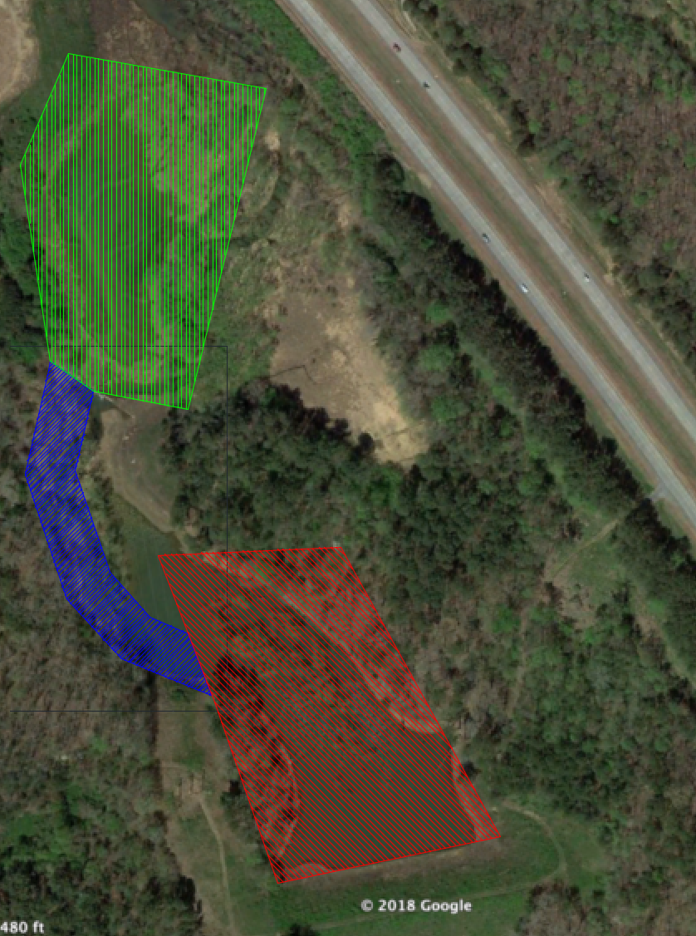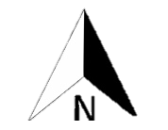

Figure 9: Reservoir Surface Area (red), Channel (blue), Forebay (green)

* + 1. Channel Reinforcement

In order to reduce the amount of sediment that is entering into the dam and prevent the issue from occurring again, erosion from the banks of the natural channel needs to be reduced or eliminated through channel redesign and reinforcement. The best option for this channel is to use a trapezoidal cross section that is lined with rip rap and a nonwoven geotextile. Rip rap protects the channel from erosion, slows the velocity of the flow, and allows for groundwater infiltration. Combined with the nonwoven geotextile, the erosion can be reduced even more. For this design, type III riprap will be used which has a median diameter of 16 inches (406.5 mm). The lining chosen is US 160 NW (a medium nonwoven geotextile). The trapezoidal cross section has a side slope of 3:1 in order to prevent the channel from caving in on itself. The final channel design includes 20% freeboard, a slope matching the current land slope of 1.7%, and was designed for the 25-year design storm (4873.32 ft3/s) per the GSWMM and WinTR-55.

Using the NRCS permissible velocity method modified for crude rip rap, the channel design has a bottom width of 33.8 feet, a normal depth of 7.0 feet during the 25-year storm event, a freeboard depth of 8.4 feet, and a top width spanning 84.3 feet. Exhibit 5 shows a sketch of the cross section. Using google maps, the length of the current channel is approximately 654 feet from the wall/waterfall feature to the entrance of the dam reservoir. Since the flow is established, the redesigned channel will follow the natural course. Using a conservative cost estimate of $1.85 per ft2 of rip rap, the cost to line the channel is $105,285. The geotextile has a cost of approximately $0.30 per ft2 creating an overall lining cost of $17,073. Based on $0.37 per ft3 for excavation, the cost to excavate the channel is approximately $120,226. This means the overall total cost to redesign the channel is $242,584. See *Figure 9* for the estimated flow path.

* + 1. Forebay Design

The forebay will be placed before the pre-existing wall structure in order to capture sediment and slow incoming stormwater runoff. The forebay will hold 0.1 inches per impervious acreage of the total drainage area. The ideal depth is 4 to 6 feet in order to promote proper settlement and sediment storage. For safety, the length to width ratio is 3:1. The forebay consists of an excavated pit and berm combined with a weir. The weir will help with slowing runoff. With all this in consideration, the volume of the forebay will be 1,103,533 ft3, while the surface area will be 183,922 ft2, assuming a depth of 6 feet. Only grasses recommended by the USDA will be used to stabilize slopes. The bottom will be hardened using concrete to make sediment removal easier. As for water quality, forebays are known to remove 25% of Total Suspended Solids (TSS). The forebay will require regular maintenance to keep its function in order.

The calculated volume of 40,872 yd3. Excavation of $10/yd3 results in $408,716, Laying concrete, using an average price of $5.75/ft2, results in $1,057,523. The rough estimate for the total cost is $1,466,269.

**Concept 3**

* Process to Returning to Original Conditions
  + Pumping station location and 7Q10
* Weir
  + How it should be sized (100 year water surface elevation = aux spillway elevation (1318.4’) pmp<4 ft above top of dam (1321.5’))
* Forebay with OCS – 102 acre ft
  + Elevation of one year storm is height of weir. Sizing based off base flow.
  + O&M Manual and path to forebay

# RecomMendations

With the different alternatives presented, GMB Engineering recommends moving forward with Concept B which is to retrofit the area to be used as a drinking water reservoir. This alternative will restore the functionality of the dam as well as provide a vital resource to the City of Jasper. We recommend this solution over the other stand-alone restoration alternatives as it is all encompassing and aligned with the goals of the client. This solution will occur in three phases: capacity sizing, channel reinforcement, and the addition of a forebay.

# Costs

|  |  |
| --- | --- |
| **Design** | **Cost** |
| A1: Excavation | $771,818 - $3,382,603 |
| A2: Dam Addition w/ Alternative Spillway | $153,515* |
| A3: Volute Siphon | Unknown |
| A4: Retrofitting Riser | Unknown |
|  |  |
| B1: Capacity Sizing | $297,049* - $415,856* |
| B2: Channel Reinforcement | $242,584 |
| B3: Forebay | $1,466,269 |
| **Concept B: Total** | $2,005,903* - $2,124,709* |

* Further analysis needed for more accurate cost estimation

# Future Work

Moving forward, a meeting with the NRCS is needed to determine which concept and design the client wants to proceed with: Concept A (fixing the dam) or Concept B (fixing the dam and turning it into a drinking water reservoir for the city of Jasper). Also, within these overall concepts, designs need to be narrowed down by the client in order to get a full scope of the goals of the client. Inundation maps need to be completed with HecRas and LiDAR data needs to be obtained from either the city or the local power company in order to determine better dimensions of the dam and reservoir GMB is working with. If LiDAR data cannot be obtained, a survey of the dam will need to be completed. Additionally, Civil 3D drawings will be completed as well as more accurate cost estimates.

# Disclaimer

The assumptions, findings, calculations, and conclusions expressed and described

in this report and its exhibits were developed by undergraduate students at the University

of Georgia who are not licensed engineers. This report was prepared as an academic

exercise as partial fulfillment of the CVLE/ENVE 4910 Senior Design course. No part of

this report should be used for planning, budgeting, construction, or fiscal-related

decisions without a complete review and written endorsement from an independent,

qualified, and licensed engineer who is willing and able to become the engineer of record

for all aspects of the study, calculations, findings, recommendations, and the project.

A complete copy of this report was provided to the client without any financial

reimbursement to its authors or the University of Georgia. The client may keep one copy

of the report and is herein given permission to copy and share the report as their needs

dictate; however, a copy of this disclaimer shall accompany all copies made. By the

acceptance and/or use of this report and the exhibits hereto, the client and all reviewers of

the content included herein shall indemnify and hold harmless the University of Georgia,

College of Engineering, University employees, and the authors of this report from any

and all liability, of whatsoever nature, that may result from such review, acceptance, and

use.

# Conclusion and SUmmary

The primary goal of this project is to provide a variety of solutions to prevent the Sharp Mountain Reservoir No.12 Dam from using the emergency spillway, thereby restoring its original function. Incorporating a drinking water reservoir, which includes appropriate reservoir capacity, channel design and lining, and forebay, into design options are also considered. Through collaboration with the NRCS and GSWCC, useful field measurements and engineering insight were provided to assist in creating and researching practical solutions. Thus far, GMB Engineering recommends moving in phases, so problems can be solved in order of importance. By partially dredging the dam, increasing the dam’s capacity, and building an alternate spillway, the dam can be repaired. Included in this report are hydrologic and hydraulic analyses, soil survey, WINTR-55 outputs, as well as sketches, calculations, codes and jurisdictions to justify GMB Engineering’s decision.

GMB Engineering would like to thank the NRCS for the opportunity to research and evaluate a real-world engineering problem, in an effort to expand our own knowledge. Please do not hesitate to contact GMB Engineering if any further questions arise.

# Exhibit 1: Site LOcation